Finance & Payments Form

How to pay for membership/ financially support A Rocha Australia

Your Name ……………..……………..…………….. Email Address ……………..…………………..………………
Postal Address ….………..……………..……………..……………..…………………..…………….………..……………..
Contact Number …..……………..……………..……………..……
Your options (please tick your choice):
  - A single one-off Electronic Funds Transfer, please transfer the total amount to this bank account:
Account Name: A ROCHA AUSTRALIA INCORPORATED
BSB: 062-818
Account No.: 10399248

Note: It is essential that you quote your name in the "payee information" text box, or we will not know who paid us. Please double check the account details as it may not be possible to reverse a payment into an incorrect account.

  - By Cheque/Money Order (Payable to ‘A Rocha Australia Inc’, mailed to c/ Tahlee Ministries Inc. Locked Bag 1, Karuah, NSW 2324).

- Entrance fee to become a member (please tick your choice):
  - $50 (adult)
  - $70 (couples without concession)
  - $20 (concession card holder)
  - $30 (couples with concession) $ ……………..

- Making a donation to the work of A Rocha Australia (optional):
Please note donations may also be made via PayPal to A Rocha Australia through the A Rocha international website: www.arocha.org/en/donate/

How much is your gift $ ……………..
TOTAL payment (A + B) $ …………..

  - Please send me information about leaving a gift in my will.
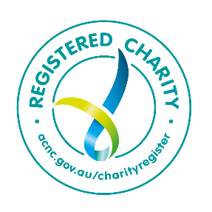
Please email a copy of this form to philip.hughes@arocha.org (Treasurer) or mail it to A Rocha Australia Incorporated c/ Tahlee Ministries Inc. Locked Bag 1, Karuah, NSW 2324

Privacy statement: The applicant agrees that the directors, staff and officers of A Rocha Australia may access the information provided in this application for the purposes of A Rocha Australia only. A Rocha Australia respects your privacy and will use its best endeavours to comply with the Privacy Act 1988 as far as reasonably possible. In particular, A Rocha Australia will not publish or forward your details to any third party without your consent.

